- Using the Following Information, estimate liquidity and solvency.

Income for the Farm was $55,000.

Assets |  | Liabilities
Current Assets | Valor | Current Liabilities | Valor
Cash | $5,000 | Loan, owed 10 months | $1,500
Pesticide | $6,000 | Credit card | $2,000
Bananas to be harvested | $20,000
Fertilizer | $3,000
A. Total de Assets Current |  | E. Total Current Liabilities
Intermediate Assets | Valor | Intermediate Liabilities | Valor
Refrigerated truck | $20,000 | Loan, owed 5 years | $21,000
Trimmer | $500
Water pump | $500
Pick-up | $29,500
Tractor | $15,000
Tractor 2016 | $40,000
B. Total Intermediate Assets |  | F. Total Intermediate Liabilities
Fixed Assets | Valor | Liabilities Fixed | Valor
20 acres of land | $150,000 | Farm Mortgage | $95,000
C. Total Fixed Assets |  | G. Total Fixed Liabilities
D. TOTAL ASSETS  (A + B + C) |  | H. TOTAL LIABILITIES  (E + F + G)
NET Worth (Owners Equity) = TOTAL ASSETS – TOTAL LIABILITIES
(D. – H.)

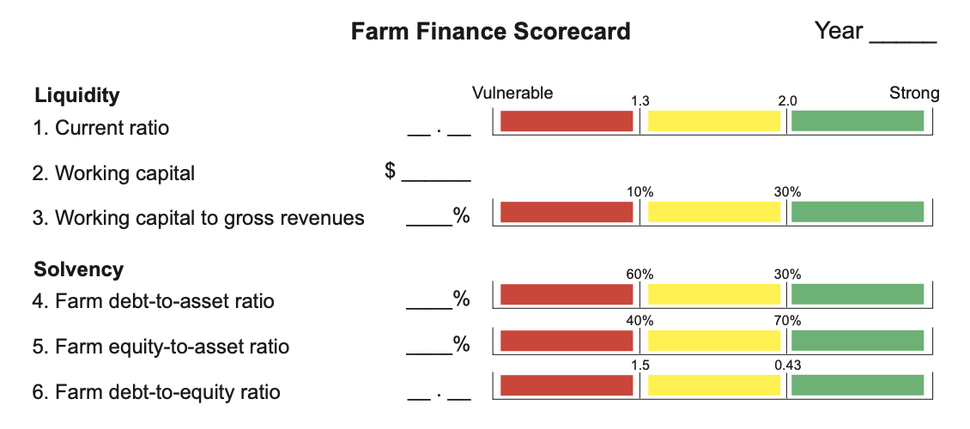

Fórmulas

Liquidez
- $Current Ratio= \frac{Total Current Assets }{Totales Current Liabilities }$
- $\text{Work}\text{ing capital}\text{= }Current Assets -Current Liabilities$
- $Working Capital to Gross Revenues Ratio= \frac{Working Capital}{Gross Income}$
Solvency
- Farm Debt-to-Asset Ratio$= \frac{Total Liabilities }{Total Assets }$
- $Farm Equity-to-Asset Ratio= \frac{Net worth}{Total Assets}$
- $Farm Debt-to-Equity Ratio=\frac{Total Liabilities}{Net worth}$
Net worth is also known as Owners Equity

- Suppose that your farm gets an incentive to build a control environment structure with a cost share of 50%, The structure has a cost of $20,000, thus the farmer has to pay $10,000. The Farmer Will take a $10,000 loan for 5years to stablish the structure. Estimate Solvency with the Increase of Fixed assets of $20,000 and Intermediate loan of $10,000 (to keep the example simple we are not including the interest).

